General  The luxurious VI1000 Digital TV STB series is specially designed by Visson and offered to make Digital TV the truly entertainment enjoyment at home. VI1000 not only has a sleek, elegant and compact exterior design but also is of full ITU Digital Video Broadcasting (DVB) compliance for Digital TV reception.  In addition to the spacious easy handling 36-key remote controller, on the front panel the 4+1 touch keys provides easy and complete access to all VI1000 functions navigation, while the status LED’s at the center gives users clear indications of all actions. And the 4-digit LED display can not just show which channel the viewer is at but also sync to the broadcaster’s clock and display the accurate time.  To conclusion, VI1000 is designed and manufactured to meet the high standard expectations of digital TV enjoyment for home entertainment. | Applications  - DVB-T Digital Terrestrial TV  - Hi-Fi Digital TV  - Digital Video Recorder (Optional w/I HDD)  - High-Speed DVB-T Modem (Optional w/I Data S/W)  Key Features and Specifications  - Nordig II and ETS 300 744 DVB-T Full Compliance  - Full 47~860 MHz Freq. Range for VHF and UHF  - OFDM Demodulation 2K / 8K FFT for SFN / MFN  - Supports QPSK and 16 / 64QAM Constellations  - Automatic Channel Scanning  - HDD Storage for PVR function (Optional)  - Multi-lingual Support w/I optional Unicode Font  - Parental Control and Favourite Program  - Easy and User Friendly User Interface  - In-the-field Air Downloader*  
ETS 300 744 DVB-T Compliance |  | Full 47~860MHz VHF / UHF Freq.
Full DVB / MPEG-2 Compliance |  | Auto-Switch QPSK / 16 / 64 QAM
Digital YCrCb and SPDIF Outputs |  | Easy & User-Friendly Navigation
Automatic Channel Scanning |  | Unicode Multi-Lingual Support*
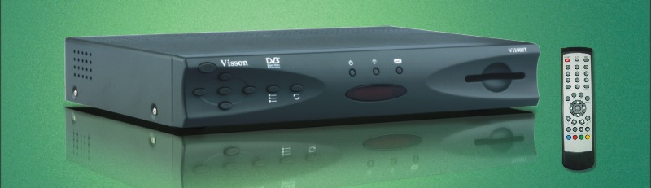

Key Features and Specifications  - Nordig II and ETS 300 744 DVB-T Full Compliance  - Full 47~860 MHz Frequency Range for VHF and UHF  - OFDM Demodulation 2K / 8K FFT for SFN and MFN  - Supports QPSK and 16 / 64 QAM Constellations  - Parental Control and Favourite Program  - HDD Storage for PVR function (Optional)  - Multi-lingual Support w/I optional Unicode Font  - Easy and User Friendly User Interface  - In-the-field Air Downloader  - Small Footprint (A4 Size)  DVB / MPEG2 Transport and De-Multiplexing  - ISO/IEC 13818-1 MPEG-2 Transport Stream Compliance  - 60Mb/s Max. Input Data Rate  - 32 User Programmable PIDs  - DVB Common Descrambler for TS and PES  Video Decoding and OSD  - ISO/IEC 13818-2 MPEG-2 Video MP@ML Compliance  - ISO/IEC 11172-2 MPEG-1 Video Compliance  - Resolution: 720x480 for NTSC and 720x576 for PAL  - 16:9/4:3, 3:2 Pull Down, Letterbox and Pan/Scan  - 8-Layer Video and Graphics planes  - 4/16/64/256 Colour (2/4/6/8-bit) OSD  Audio Decoding  - ISO/IEC 13818-3 MPEG-2 Audio Compliance  - ISO/IEC 11172-3 MPEG-1 Audio Compliance  - Single / Dual / Joint Stereo / Stereo  - Sampling Rate Up To 48 KHz  - Supports Linear PCM Sample Rates Up to 96KHz  Return Channel (Optional)  - Comm. Protocol: TCP/IP-PPP, HTTP or Propriety  - Cable Modem or ADSL Modem (via Ethernet); or,  - V.22/V.24 PSTN Modem | Network Interface Module – DVB-T COFDM  - Nordig II and ETS 300 744 DVB-T Compliance  - Full 47~860 MHz Frequency Range for VHF and UHF  - OFDM Demodulation 2K / 8K FFT for SFN and MFN  - Symbol Rates : up to 34 MS/s  - Automatic Adjacent-Channel Interference Cancellation  - Supports QPSK and 16/64QAM Constellations  - Supports 1/4, 1/8, 1/16, 1/32 Guard Interval  - Supports FEC Decoding : 1/2, 2/3, 3/4, 5/6 and 7/8  - Supports Reed-Solomon (204,188) ETS 300 477  - Automatic Channel Scanning  Front Panel  - 4-Digit LED Display  - Power, Remote and Lock LED’s  - 4+1 Keys (Vol, Channel, OK, Menu Access, Menu Exit)  - Power On/Off Button  - ISO 7816 Smart Card Interface Slot (Optional)  Rear Panel  - Antenna in : F-type  - RCA Composite or SCART A/V Output  - S-Video Video Output  - Data I/F: USB Connector  - Power On/Off Switch  - AC Power Jack In  Safety and Reliability  - EMC : According to the Regional Approbation Rules  - Safety : According to IEC65  - Operation temperature : +5°C ~ +40°C  - Storage temperature : -10°C ~ +70°C  Power Supply (per regional requirement)  - 50Hz or 60Hz, 115 or 230V, +/- 10% Single Voltage  - Power Consumption: 35 Watts Max.  Mechanical Specification  - Dimensions (WxDxH): 310mm x 215mm x 50mm  - Weight : 1.1 kg
For more information, please contact:
Visson Technologies Inc. Tel.: +886-2-2218-8010
7F, 96, Min Chuan Rd., Hsin-Tien Fax: +886-2-2218-8020

Taipei Hsien, Taiwan. R.O.C. EMail: VissonInfo@via.com.tw

